Plant species interactions at an ecotone

Keryn B. Gedan, Whitney Hoot, and Eduardo Fernández-Pascual

Peters et al 2006 Integrating patch and boundary dynamics to understand and predict biotic

transitions at multiple scales

ERM – Edge Response Model (Ries and Sisk 2004): Transitional (declining across edge into foreign habitat), Neutral, and Positive response expectations

Try to extrapolate from ERM to species interactions?

If a species exhibits a positive edge response, due to the presence of complementary resources in adjacent habitats, species interactions may become more competitive across the ecotone, as species compete for access a critical resource. If a species exhibits a negative edge response, indicating lower quality adjacent habitat, we might expect more facilitative species interactions…for example if water is less available in an adjacent habitat but the presence of other species retains greater water in the soil…

**Introduction**

**\*\* Introduce edge effects and ecotones and broadly outline the ecological research space**

The study of habitat edges, or ecotones, remains a topic of high interest in ecology (Ries et al. 2017). At ecotones, where disparate communities of organisms meet and overlap, there are few generalizable rules about what type of ecological interactions to expect, and novel interactions are often expected. Some trophic interactions, such as bird nest parasitism, exhibit interesting patterns at habitat edges (XXX). However, there has been little investigation of species interactions between species within the same trophic level in ecotones (Ries et al. 2017). A specially overlooked type of interaction is facilitation, which nonetheless is expected to occur in situations where environmental stress is high (Brooker et al. 2008 J. of Ecology). High stress is a natural characteristic of ecotones, which represent a shift in abiotic conditions and available resources, and are thus stressful for the communities that meet there.

The environmental stress gradient hypothesis suggests more intense competition where stress is low and more facilitative interactions where stress is high (REFERENCE). This process is responsible for structuring ecosystems along strong and universal stress gradients, forming stark community patterns such as zonation (REFERENCE).

**\*\*community interaction networks**

Silander and Antonovics 1982 Nature…

At the tidal marsh-upland ecotone, there are two abiotic gradients relevant to plants that exhibit major shifts: 1) salinity, which declines from the saline tidal marsh to the nonsaline upland forest, and 2) light availability, which declines from the low stature, graminoid community of the tidal marsh to the sub-canopy shrub-herbaceous community of the upland forest. Although salinity is a universal stress for terrestrial plant species, salinity stress will have a more negative effect on glycophytic upland plants relative to halophytic marsh plants. On the other hand, low light availability, also a universal challenge for photosynthetic plants, is likely to have a more negative effect on marsh plants, which generally occur in open sun environments and have high light demand.

**\*\* The Edge Response Model (ERM) is also relevant** in predicting the response of individual species across an ecotone, and predicts that species will be affected by resource gradients that shift across the ecotone.

** **Why study this in tidal marsh-upland ecotones?**

In this study, we sought to characterize plant interactions across the ecotone between tidal marsh and upland forest. In our study region of the Chesapeake Bay (USA), this ecotone is rapidly shifting due to sea level rise, as tidal marsh migrates inland (Scheider et al. 2017). Therefore, understanding species interactions across this ecotone may help us to understand the biotic and abiotic controls on species distributions within these dynamic ecosystems, and could also elucidate management options with the goal of conserving tidal marsh ecosystems in the face of accelerated sea level rise (Kirwan and Megonigal 2013). For example, if species interactions on the upland edge of the ecotone are largely competitive for marsh plants, then clearing upland plants may reduce competition for migrating individuals and increase the rate or success of migration. Similarly, if interactions are largely facilitative along this boundary, then we would expect that clearing plants in the way of migrating marsh plants would negatively affect migration outcomes. This is particularly relevant as forest clearing is being considered as a management alternative to increase marsh migration. The rationale for this management tactic is altering the light environment at ground level, which is thought to favor marsh plant success. However, evidence for this assumption is scarce.

**\*\* Describe the specific study done here and its two parts (greenhouse and field)**

We asked the question of whether the environmental stress gradient hypothesis can be applied across an ecotone where strong and universal stress gradients exist. We examined pairwise interactions of species commonly found along the tidal marsh-upland ecotone in a controlled greenhouse environment where we could manipulate abiotic factors to mimic opposing sides of the edge, and tease apart the effects of light availability and salinity stress, while controlling for many other factors. We also surveyed field conditions where forest canopy cover had been experimentally disturbed to test the effect of two abiotic stresses on the productivity of a common edge species, *Spartina patens*, across the ecotone of intact and disturbed edge sites.

Q1: How do plant species from adjacent ecosystems interact?

* + H1: marsh plants and upland plants will compete, based on the ESG hypothesis

Q2: How will interactions shift across the ecotone, based on environmental gradients?

* + H1: salinity will stress upland more than salt marsh plant species
  + H2: reduced light availability will stress tidal marsh relative to upland plant species

**\*\* Describe hypotheses for each part, bringing in the ESG hypothesis**

In the greenhouse experiment, we test whether there is a consistent direction for interactions between species associated with different habitats (e.g. a marsh native or upland native).

**Materials and Methods**

*Field site*

Field work was conducted at Moneystump Marsh in the Blackwater National Wildlife Refuge in Dorchester County, Maryland, USA. The site is a brackish marsh surrounded by wet loblolly pine (*Pinus taeda*) forest. Blackwater NWR land cover has experienced large changes in the last century that include a high degree of marsh loss (Stevenson et al. 1985) and marsh migration (Scott et al. 2009, Lennert et al. 2017). Changes have been attributed to high rates of relative sea level rise, which are 4 to 10 mm/yr (Ezer and Corlett 2012), well above the global average (Sallenger et al. 2012), as well as plant disturbance by the invasive consumer *Myocastor coypus*, which was recently eradicated.

*Environmental gradient characterization*

Variation in light availability across the ecotone was compared at (1) the high marsh edge, (2) mid-ecotone, and (3) within the forest edge, at three sites within Moneystump Marsh. The three sites were within 1 km of one other. Two sites (“Control East” and “Control West”) had intact marsh-upland ecotones. At the third site (“Forest Cut”), 3 ha of forest had been experimentally cut in August 2014, as part of a forest disturbance and marsh migration experiment. Site conditions at Forest Cut were similar to Control East and Control West in all regards, except the light availability in the forest edge, and other conditions indirectly affected by light availability, such as soil temperature and humidity. Differences between the two control sites and the forest cut site are informative because they indicate the role of canopy cover in affecting abiotic conditions on the forested side of the ecotone.

High marsh edge, mid-ecotone, and forest edge locations across the ecotone were determined based on the plant community, with the high marsh edge characterized by the indicator species *Spartina patens* and *Iva frutescens*, the mid-ecotone characterized by *Panicum virgatum* and *Baccharis halimifolia*,and the forest edge characterized by *Pinus taeda* tree cover and reduced herbaceous ground cover. To characterize the light gradient across the ecotone, light measurements were collected at all points at the Control East site at 100 cm height using an Apogee light meter.

To characterize variation in salinity across the ecotone, soil porewater (n = 6) was collected from the top 5cm of the soil at six points within each location (high marsh, mid-ecotone, and forest edge) at each site (Control East, Control West, and Forest Cut) during a neap tide in July using a syringe, and porewater salinity was measured on a handheld refractometer.

*Field biomass production*

In June, we collected aboveground biomass of naturally occurring *S. patens* from five haphazardly selected 10 x 10 cm quadrats at each location within each site to investigate the effects of salinity and light availability on natural *S. patens* biomass production. At all sites, *S. patens* oftengrew in a mixture with *Distichlis spicata.* Aboveground biomass of *S. patens* and *D. spicata* was dried in a drying oven at 60 °C until constant mass, and weighed.

*Greenhouse experiment*

Based on their occurrence at the field site, we selected six plant species that were common along the ecotone for which to investigate pairwise species interactions in a greenhouse experiment. Of these six species, two were more prevalent along the upland forest edge (*Panicum virgatum* and *Phragmites australis*) and four were more prevalent in the tidal marsh (*Spartina alterniflora*, *Spartina patens*, *Distichlis spicata*, and *Schoenoplectus americanus*),

Plants were purchased as 5 cm x 5 cm plugs from a plant nursery (Environmental Concern, St. Michaels, MD). All species were commercially available except two: *Schoenoplectus americanus*, which was substituted with the close congener *Schoenoplectus pungens*, which is ecologically similar and was commercially available, and the invasive species *Phragmites australis*, which was grown from seed that was collected at the field site in November the year prior. At the beginning of the experiment, eight individuals of each plant species were dried and weighed to determine initial biomass.

To test all pairwise interactions between upland and tidal marsh species, plants were grown in pots, either alone or with a species from the adjacent habitat, resulting in 14 neighbor combinations (Table 1). All experimental pots were 11.4 x 11.4 x 15.2 cm (w x l x d) and contained one or two individual plants. Roots of plugs were gently separated before repotting alone or with a neighbor in a matrix of Px-1 Metro Mix Soil.

All plants were repotted within one week and transferred to a greenhouse bay where they were watered with fresh water. At the end of 10 days of recovery from transplant stress, plants were transferred to trays without drainage holes to mimic flooded conditions. Each tray contained all 14 neighbor combinations. One week later, we started the shade and salinity treatments to mimic the shift in abiotic conditions that occurs across the ecotone.

To mimic the soil salinity of deep forest, forest edge, and tidal marsh, we watered individual trays with 0, 3, and 6 psu water. Salinities were achieved by adding Instant Ocean salt to tap water. To gently acclimate plants to salinity treatments, the salinity of the 3 and 6 psu treatments was raised gradually, from 0 to 1 to 3 to 6 psu over eight days. Trays were drained and re-watered with the assigned salinity every 3 days to maintain treatment levels and prevent the build-up of excessive porewater salinity through evapotranspiration.

To mimic the shade of deep forest, forest edge, and tidal marsh, shade tents were placed above the trays of neighbor combinations. Shade tents were 1.6 x 1.0 x 1.3 m (w x l x h), and were built from a PVC pole frame with a roof of 75% shade cloth (Heavy Green Sun Fabric, Easy Gardener) that overhung the sides of the frame by 0.5 m on all sides. Shade treatments had three levels: ambient light (tent frame without a shade), 75% reduction in ambient light (single layer of shade cloth), and 90% reduction in ambient light (double layer of shade cloth). There were four replicates of each level of shade. Each shade tent housed six trays, two of each salinity level. To ensure the expected abiotic conditions were met, regular measurements were made of light in all shade treatments with a handheld light meter (Apogee Instruments) and of salinity in all water reservoirs using a refractometer.

The experimental treatments were continued for 16 weeks, during which treatments were regularly rotated around the room to avoid orientation or room biases, before plants were harvested. To separate roots and disentangle roots of neighboring plants for biomass measurements, plant roots were power washed to remove soil. Individual plants were dried in a drying oven at 60 °C until constant mass, separated into above and belowground biomass, and weighed.

*Statistical analysis*

Biomass

Root:Shoot ratios

Relative interaction index

Statistics: Type III ANOVA for the greenhouse experiment – this is going to be a problem, since technically there was blocking (of salinity treatments within shade treatments). Do we need to design a different ANOVA? Main effects of Neighbor identity, shade, salinity, and all interactions.

**Results**

**Environmental gradient characterization**

Salinity varied across the ecotone gradient from 2 to 6 psu. Salinity exhibited a gradient across the ecotone, significantly higher at the marsh edge relative to the ecotone and the forest edge (main effect of location, ANOVA Table). At the forest cut site, this salinity gradient was greatly muted (Fig. 5) and there was no significant difference in salinity between the forest and marsh (Location x Site effect, ANOVA Table). There was also a significant effect of neighbor removal on salinity (Neighbor effect, ANOVA Table) but the effect was small in magnitude, with neighbor removal plots exhibiting porewater salinities that were an average of 0.4 psu lower than neighbor intact plots. Light also varied across the ecotone (ANOVA Table); the forest location received 67% of the light available in the marsh location (Fig. 5).

Midsummer plant biomass of *S. patens* and *D. spicata* varied across the ecotone and due to the effect of forest disturbance (Fig. 6). At the two control sites, biomass was significantly lower in the forest relative to the ecotone and marsh, but there was no significant difference between locations at the cut site (interactive effect of Site x Location, ANOVA Table).

**Greenhouse experiment**

*Biomass*

Productivity of *Phragmites australis*, which was started from seed. Initial biomass data

There was a main effect of neighbor identity on the biomass production of all species. All species were more productive when they were grown alone than when they were grown with neighbors.

Shade also had an effect on the biomass production of all species. Species were more productive in the ambient light condition than shade conditions.

Salinity negatively affected biomass production in only two species, *Panicum virgatum* and *Schoenoplectus pungens*.

There were a few interactive effects. The most common was a Neighbor x Shade interaction, which had a significant effect on biomass production of *D. spicata, P. australis, S. alterniflora* and *S. patens.* This interaction occurred when shading treatments had a larger effect on biomass production when the species was grown alone than when it was grown with neighbors.

*Root:shoot ratios*

Root:shoot ratios exhibited a similar pattern. Neighbor identity was the strongest predictor in ANOVA, and was highly significant (p < 0.001) for four of six species. Most species allocated greater investment in roots when grown with another species.

Shade also had a large effect on root:shoot ratios, affecting five of six species. All species except *Phragmites australis* allocated more resources to aboveground growth in response to shade. The root:shoot ratios of *P. australis* exhibited a number of unique responses among the experimental species that are likely an artifact of very low biomass values for both roots and shoots. The average root biomass of *P. australis* was xxx. The average shoot biomass was xxx.

Changes in root:shoot ratios were especially pronounced for *Schoenoplectus pungens*. This species halved its root:shoot ratio when grown in the shade relative to when it was grown in ambient sun.

Salinity had no effect on root:shoot ratios.

*RII species interactions index*

With very few exceptions, the species interactions, as indicated by the RII, were negative.

*Need help here.*Having trouble interpreting Table 3: I am not clear how we can have one model for Pa x Ds/Sp/Sa/Schp but no model for Ds/Sp/Sa/Schp x Pa…The relative interaction index is focal species specific – it is calculated for both partners, but in the stats summary table, we only provide one test statistic for each neighbor pairing and the various treatments. We have pairs where RII is positive in one direction and negative in another; are these treated as a single response in the ANOVA model?

**Discussion**

For both Panicum and Phragmites, we did observe higher growth rates in deeper shade than in sun in Justus' transplant experiment (data in his recent Ecology paper). In that case, we assumed that the growth response in shade was a result of it also being lower salinity, so we attributed the increased growth to lower salinity stress. But this V-shaped curve makes me wonder. Still, it would be good to see with the confidence intervals before getting too speculative.

About S. alterniflora, I’m thinking that this species is a classical stress-tolerant plant, and thus a poor competitor. So, rather than “not taking a dip”, perhaps it is that it is not profiting too much from the full light: it has a conservative metabolism independently of light (I imagine it is spending a lot of resources in its salt and flood adaptations).

**What were our findings?**

Interactions were more frequently competitive than facilitative.

Facilitation was more common in shade and in salinity the “more stressful ends” of the ecotone gradient.

Facilitative interactions were not bidirectional; where facilitation occurred, it was unilateral and the opposing direction had weak competition.

In high salinity and high light, Spartina alterniflora facilitated Panicum virgatum. This is a result that would be predicted by the ESG hypothesis.

**Caveats – second half of discussion**

In deep shade (90%), the two upland species, P. virgatum and P. australis, facilitated other species, namely Distichlis spicata and Schoenoplectus pungens. Why would this happen? Perhaps this could be explained by neighbor mediated water use reducing flooding? We don’t have the data to support this. Alternatively, but seems unlikely given the positive effect of light on biomass production, shading could reduce thermal stress in the greenhouse environment.

Facilitative interactions are defined on the basis of benefit to one or both partners and harm to none (Bruno et al. 2003). However, species interactions, inherently multi-dimensional across multiple shared resource and stress gradients, can be uneven or mixed positive and negative effects (e.g. Holzapfel and Mahall 1999). We observed several of those types of interactions here. (Although they were positive in one direction and negative in another, it would be more correct to call them uneven than parasitism…I think )

**Possible critiques that we could consider heading off in the discussion**

Lortie and Callaway (2006)’s critique of stress gradients of various lengths being lumped together. Do the shade gradient and salinity gradient represent “equivalent” lengths? They were based on the reality of the system, but of course, this is just one systems – salinity gradients can be more extreme in euhaline marsh-upland boundaries, and shade gradients would be more extreme in marsh-deciduous forest ecotones. He and Bertness (2014): environmental gradients versus stress gradients

Biomass does not equal fitness (Goldberg et al. 1999)…

Pairwise approach does not account for the possibility of competitive suppression of a competitor, known as indirect facilitation…

**Table 1.** The fourteen species combinations grown in the greenhouse experiment. Species labelled in green are of marsh origin, orange are of upland origin, and red are marsh x upland combinations.

|  |
| --- |
| Neighbor combinations |
| *Spartina alterniflora* alone |
| *Spartina patens* alone |
| *Schoenoplectus pungens* alone |
| *Distichlis spicata* alone |
| *Phragmites australis* alone |
| *Panicum virgatum* alone |
| *S. alterniflora x P. australis* |
| *S. patens x P. australis* |
| *Sch. pungens x P. australis* |
| *D. spicata x P. australis* |
| *S. alterniflora x P. virgatum* |
| *S. patens x P. virgatum* |
| *Sch. pungens x P. virgatum* |
| *D. spicata x P. virgatum* |

**Table 2.** ANOVA table for the effect of location, vegetation, and site, and all interactions, on porewater salinity.

|  |  |  |  |  |
| --- | --- | --- | --- | --- |
| Term | d.f. | Sum Sq | F | p |
| Location | 2 | 26.54 | 18.806 | **1.16E-06** |
| Neighbor | 1 | 3.14 | 4.456 | **0.04036** |
| Site | 2 | 2.91 | 2.064 | 0.13879 |
| Location x Neighbor | 2 | 1.92 | 1.361 | 0.26668 |
| Location x Site | 4 | 11.43 | 4.051 | **0.00687** |
| Neighbor x Site | 2 | 2.26 | 1.601 | 0.21295 |
| Location x Neighbor x Site | 4 | 1.47 | 0.521 | 0.72045 |
| Residuals | 45 | 31.75 |  |  |

**Table XX REMOVE**. ANOVA table for the effect of location on light at the Control East site.

|  |  |  |  |  |
| --- | --- | --- | --- | --- |
| Term | d.f. | Sum Sq | F | p |
| Location | 2 | 1889780 | 12.72 | **7.53E-05** |
| Residuals | 34 | 2526416 |  |  |

**Table 3.** ANOVA table of the effect of site and location and their interaction on midsummer biomass of *Spartina patens* and *Distichlis spicata*

|  |  |  |  |  |
| --- | --- | --- | --- | --- |
| Term | d.f. | Sum Sq | F | p |
| Site | 2 | 0.01 | 0.003 | 0.997 |
| Location | 2 | 47.74 | 17.715 | **5.36E-06** |
| Site x Location | 4 | 22.75 | 4.222 | **0.007** |
| Residuals | 34 | 45.81 |  |  |

**BIOMASS TABLES AND FIGURES**

**Table 4.** Effect of neighbor, shade and salinity on the biomass of each study species. The table indicates the significance levels of the terms of a fully factorial type-III ANOVA fitted to the biomass data of each species. NS = p > 0.1; . = p > 0.05; * = p > 0.01; ** = p > 0.001; *** = p < 0.001.

|  |  |  |  |  |  |  |
| --- | --- | --- | --- | --- | --- | --- |
| Model term | *D. spicata* | *Ph. australis* | *P. virgatum* | *S. alterniflora* | *S. patens* | *Sch. pungens* |
| Neighbor identity (Ne) | *** | *** | *** | *** | *** | ** |
| Shade (Sh) | * | . | *** | . | *** | *** |
| Salinity (Sa) | NS | NS | ** | NS | NS | *** |
| Ne x Sh | ** | * | NS | * | . | NS |
| Ne x Sa | NS | NS | * | NS | NS | NS |
| Sh x Sa | NS | NS | . | NS | NS | NS |
| Ne x Sh x Sa | NS | NS | NS | NS | NS | NS |

**ROOT:SHOOT TABLES AND FIGURES**

**Table 5.** Effect of neighbor, shade and salinity on the roots:shoots ratio of each study species. The table indicates the significance levels of the terms of a fully factorial type-III ANOVA fitted to the roots:shoots ratio of each species. NS = p > 0.1; . = p > 0.05; * = p > 0.01; ** = p > 0.001; *** = p < 0.0001.

|  |  |  |  |  |  |  |
| --- | --- | --- | --- | --- | --- | --- |
| Model term | *D. spicata* | *Ph. australis* | *P. virgatum* | *S. alterniflora* | *S. patens* | *Sch. pungens* |
| Neighbor (Ne) | *** | NS | NS | *** | *** | *** |
| Shade (Sh) | * | NS | * | * | * | *** |
| Salinity (Sa) | NS | *** | NS | NS | NS | NS |
| Ne x Sh | . | ** | NS | NS | NS | NS |
| Ne x Sa | NS | ** | NS | NS | NS | NS |
| Sh x Sa | NS | NS | NS | . | NS | NS |
| Ne x Sh x Sa | NS | *** | NS | NS | NS | NS |

**RII TABLES AND FIGURES**

**Table 6.** Effect of neighbor identity, shade and salinity on the relative interaction intensity (RII) for each of the eight combinations of upland and marsh species growing together. The table indicates the significance levels of the terms of a fully factorial type-III ANOVA fitted to the RII of each species combination. NS = p > 0.1; . = p > 0.05; * = p > 0.01; ** = p > 0.001; *** = p < 0.001.

|  |  |  |  |  |  |  |  |  |  |  |
| --- | --- | --- | --- | --- | --- | --- | --- | --- | --- | --- |
|  | *Ph. australis* x | | | | |  | *P. virgatum* x | | | |
| Model term | *D. spicata* | *S. alterniflora* | *S. patens* | *Sch. pungens* | |  | *D. spicata* | *S. alterniflora* | *S. patens* | *Sch. pungens* |
| Neighbor (Ne) | *** | ** | *** | *** |  |  | NS | *** | NS | *** |
| Shade (Sh) | ** | NS | NS | NS |  |  | NS | NS | NS | NS |
| Salinity (Sa) | NS | NS | NS | NS |  |  | . | NS | NS | NS |
| Ne x Sh | NS | NS | NS | NS |  |  | * | ** | NS | NS |
| Ne x Sa | NS | NS | NS | * |  |  | NS | NS | NS | NS |
| Sh x Sa | NS | NS | NS | NS |  |  | NS | NS | NS | NS |
| Ne x Sh x Sa | NS | NS | NS | NS |  |  | NS | NS | NS | NS |

 

**Figure 1.** Variation in porewater salinity (left) and light availability (right) at field sites and locations.



**Figure 2.** Midsummer biomass of *Spartina patens* and *Distichlis spicata* at the field sites and locations.

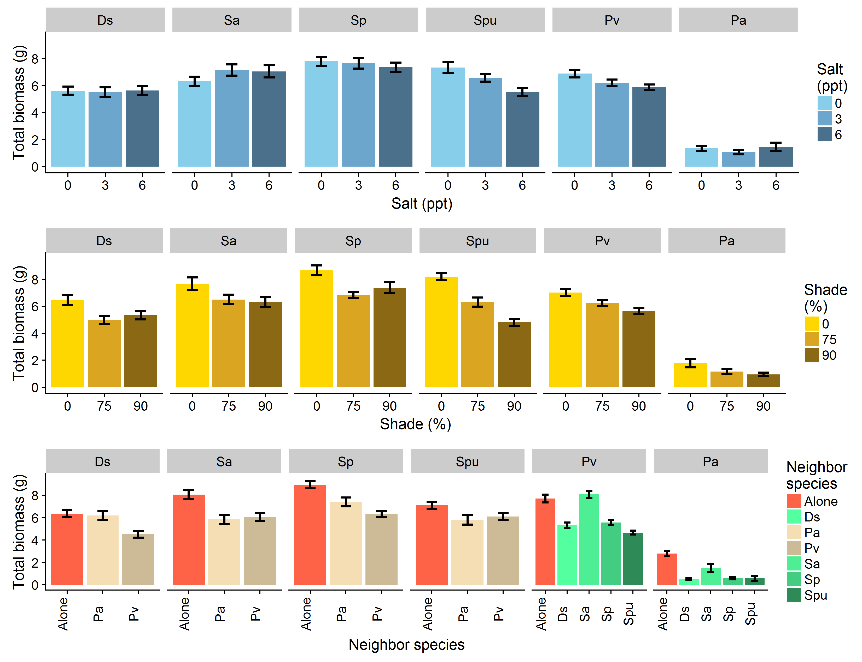

**Figure 3.** Total biomass of each study species at the end of the experiment. Showing only the main effects of the three factors. Each species grew alone or accompanied by a neighbor species (indicated inside the grey boxes), and at different levels of shade and salinity. Salinity levels are only represented for those species in which this factor had a significant effect (i.e., *Schoenoplectus pungens* and *Panicum virgatum*); in the rest, the results are the average of the three levels. Bars represent the average biomass per treatment, brackets are SE.

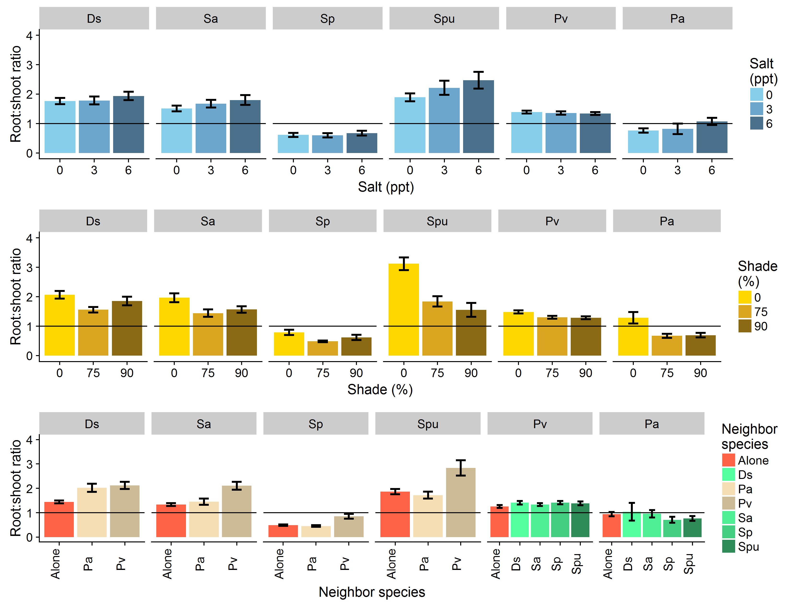

**Figure 4.** Showing only the main effects of the three factors (and the brackets are SE). Roots:shoots ratio of each study species at the end of the experiment. Each species grew alone or accompanied by a neighbor species (indicated inside the grey boxes), and at different levels of shade and salinity. Salinity levels are only represented for the species in which this factor had a significant effect (i.e., *Phragmites australis*); in the rest, the results are the average of the three levels. Bars represent the average roots:shoots ratio per treatment, brackets are SE.

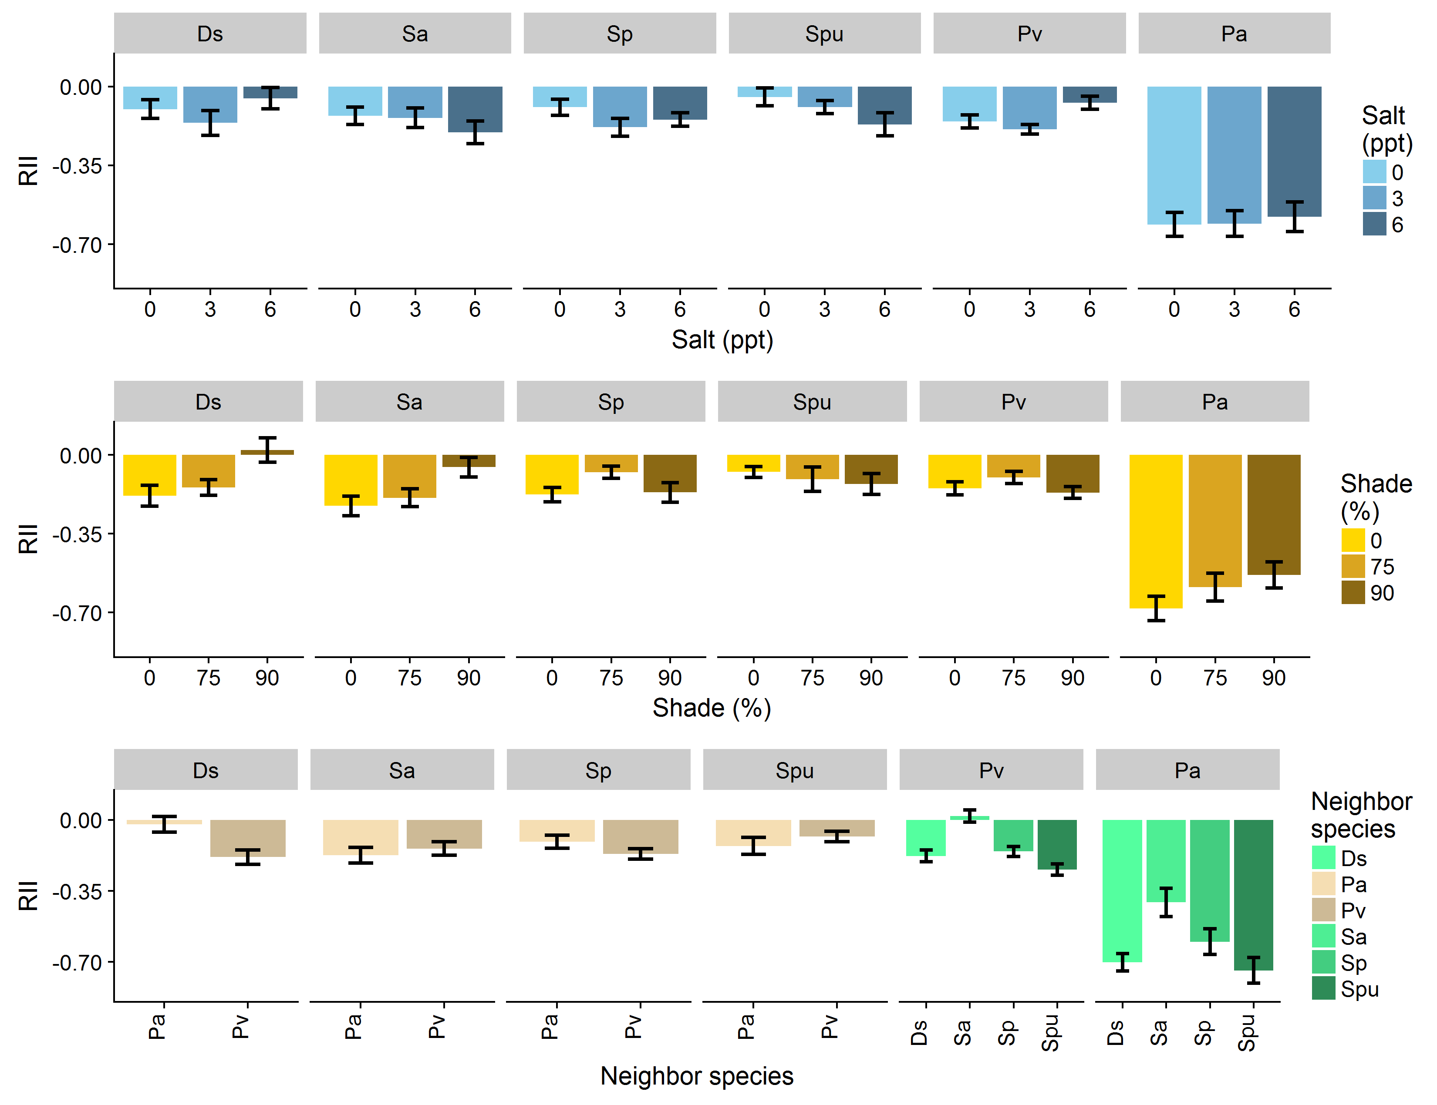­

**Figure 5.** Main effects of the three factors are shown, and the figure is organized by species instead of combo (and brackets are SE). Relative interaction intensity (RII) of each combination of upland (*Ph. australis*, *P. virgatum*) and marsh (*D. spicata*, *S. alterniflora*, *S. patens*, *Sch. pungens*) species growing together. Each combination was grown at different levels of shade and salinity. Bars represent the average RII per species and treatment, brackets are SE.

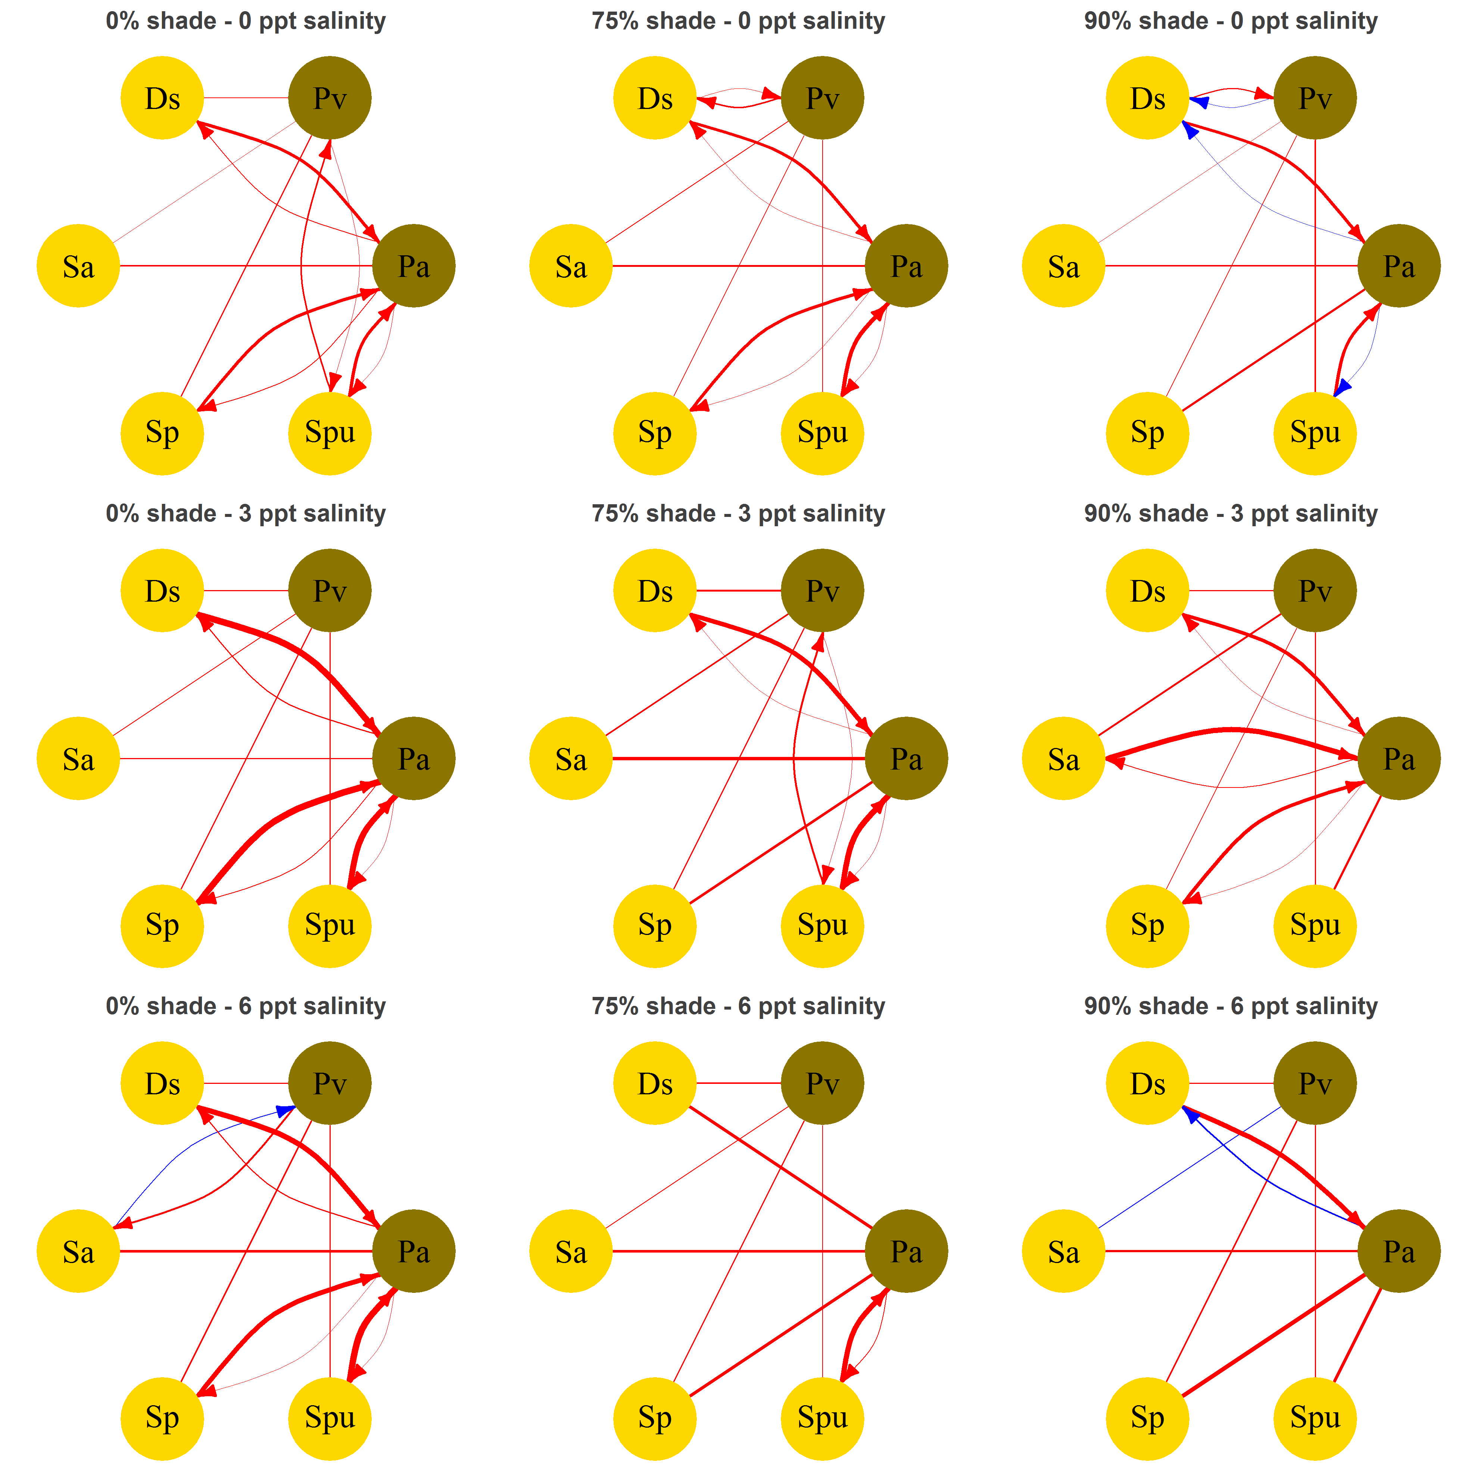

**Figure 6.** Network of relative interaction intensities (RII) between two upland species (*Phragmites australis* = Pa, *Panicum virgatum* = Pv) and four marsh species (*Distichlis spicata* = Ds, *Spartina alterniflora* = Sa, *S. patens* = Sp, *Schoenoplectus pungens* = Spu). The species were grown together in pairs at different levels of shade and salinity. Straight links indicate that the pairwise RIIs were not significantly different (p > 0.005). Curved links indicate that the pairwise RIIs were different. Blue links indicate facilitation interactions (RII > 0); red links indicate competition interactions (RII < 0).

**Supplementary Materials**

**Table S1** Full ANOVA table for the effect of neighbor, shade and salinity on the biomass of each study species. The table provides the values of type-III ANOVAs fitted to the biomass data of each species.

|  |  |  |  |  |  |
| --- | --- | --- | --- | --- | --- |
| Species | Term | d.f. | Sum Sq | F | p |
| *D. spicata* | Neighbor | 2 | 142.593 | 13.127 | **< 0.001** |
|  | Shade | 2 | 37.772 | 3.477 | **0.033** |
|  | Salinity | 2 | 0.921 | 0.085 | 0.919 |
|  | Neighbor x Shade | 4 | 93.458 | 4.302 | **0.003** |
|  | Neighbor x Salinity | 4 | 11.894 | 0.548 | 0.701 |
|  | Shade x Salinity | 4 | 9.549 | 0.440 | 0.780 |
|  | Neighbor x Shade x Salinity | 8 | 26.970 | 0.621 | 0.759 |
|  | Residuals | 151 | 820.117 |  |  |
| *Ph. australis* | Neighbor | 4 | 116.680 | 15.739 | **< 0.001** |
|  | Shade | 2 | 11.188 | 3.018 | 0.053 |
|  | Salinity | 2 | 3.995 | 1.078 | 0.344 |
|  | Neighbor x Shade | 8 | 36.603 | 2.469 | **0.017** |
|  | Neighbor x Salinity | 8 | 8.500 | 0.573 | 0.798 |
|  | Shade x Salinity | 4 | 2.167 | 0.292 | 0.882 |
|  | Neighbor x Shade x Salinity | 16 | 18.376 | 0.620 | 0.862 |
|  | Residuals | 105 | 194.607 |  |  |
| *P. virgatum* | Neighbor | 4 | 621.937 | 36.013 | **< 0.001** |
|  | Shade | 2 | 111.866 | 12.955 | **< 0.001** |
|  | Salinity | 2 | 53.562 | 6.203 | **0.002** |
|  | Neighbor x Shade | 8 | 32.302 | 0.935 | 0.488 |
|  | Neighbor x Salinity | 8 | 69.185 | 2.003 | **0.046** |
|  | Shade x Salinity | 4 | 39.106 | 2.264 | 0.062 |
|  | Neighbor x Shade x Salinity | 16 | 60.966 | 0.883 | 0.590 |
|  | Residuals | 296 | 1277.968 |  |  |
| *S. alterniflora* | Neighbor | 2 | 185.495 | 11.284 | **< 0.001** |
|  | Shade | 2 | 44.197 | 2.689 | 0.071 |
|  | Salinity | 2 | 25.438 | 1.548 | 0.216 |
|  | Neighbor x Shade | 4 | 85.165 | 2.590 | **0.039** |
|  | Neighbor x Salinity | 4 | 29.767 | 0.905 | 0.463 |
|  | Shade x Salinity | 4 | 10.285 | 0.313 | 0.869 |
|  | Neighbor x Shade x Salinity | 8 | 80.861 | 1.230 | 0.286 |
|  | Residuals | 148 | 1216.414 |  |  |
| *S. patens* | Neighbor | 2 | 244.948 | 23.636 | **< 0.001** |
|  | Shade | 2 | 97.138 | 9.373 | **< 0.001** |
|  | Salinity | 2 | 8.320 | 0.803 | 0.450 |
|  | Neighbor x Shade | 4 | 44.589 | 2.151 | 0.077 |
|  | Neighbor x Salinity | 4 | 16.844 | 0.813 | 0.519 |
|  | Shade x Salinity | 4 | 11.734 | 0.566 | 0.688 |
|  | Neighbor x Shade x Salinity | 8 | 47.165 | 1.138 | 0.342 |
|  | Residuals | 146 | 756.512 |  |  |
| *Sch. pungens* | Neighbor | 2 | 41.573 | 5.576 | **0.005** |
|  | Shade | 2 | 307.715 | 41.276 | **< 0.001** |
|  | Salinity | 2 | 94.545 | 12.682 | **< 0.001** |
|  | Neighbor x Shade | 4 | 20.155 | 1.352 | 0.254 |
|  | Neighbor x Salinity | 4 | 6.330 | 0.425 | 0.791 |
|  | Shade x Salinity | 4 | 19.755 | 1.325 | 0.264 |
|  | Neighbor x Shade x Salinity | 8 | 17.704 | 0.594 | 0.782 |
|  | Residuals | 136 | 506.946 |  |  |

**Table S2** Full ANOVA table for the effect of neighbor, shade and salinity on the roots:shoots ratio of each study species. The table provides the values of type-III ANOVAs fitted to the roots:shoots ratio of each species.

|  |  |  |  |  |  |
| --- | --- | --- | --- | --- | --- |
| Species | Term | d.f. | Sum Sq | F | p |
| *D. spicata* | Neighbor | 2 | 18.092 | 10.963 | **< 0.001** |
|  | Shade | 2 | 5.988 | 3.629 | **0.029** |
|  | Salinity | 2 | 1.211 | 0.734 | 0.482 |
|  | Neighbor x Shade | 4 | 7.376 | 2.235 | 0.068 |
|  | Neighbor x Salinity | 4 | 1.718 | 0.521 | 0.721 |
|  | Shade x Salinity | 4 | 4.573 | 1.386 | 0.242 |
|  | Neighbor x Shade x Salinity | 8 | 8.394 | 1.272 | 0.262 |
|  | Residuals | 151 | 124.594 |  |  |
| *Ph. australis* | Neighbor | 3 | 1.136 | 1.679 | 0.176 |
|  | Shade | 1 | 0.047 | 0.209 | 0.649 |
|  | Salinity | 1 | 2.749 | 12.194 | **0.001** |
|  | Neighbor x Shade | 7 | 4.934 | 3.126 | **0.005** |
|  | Neighbor x Salinity | 7 | 5.277 | 3.344 | **0.003** |
|  | Shade x Salinity | 3 | 0.324 | 0.478 | 0.698 |
|  | Neighbor x Shade x Salinity | 15 | 15.939 | 4.713 | **< 0.001** |
|  | Residuals | 104 | 23.448 |  |  |
| *P. virgatum* | Neighbor | 4 | 1.237 | 1.024 | 0.395 |
|  | Shade | 2 | 2.776 | 4.594 | **0.011** |
|  | Salinity | 2 | 0.157 | 0.259 | 0.772 |
|  | Neighbor x Shade | 8 | 3.045 | 1.260 | 0.264 |
|  | Neighbor x Salinity | 8 | 0.533 | 0.220 | 0.987 |
|  | Shade x Salinity | 4 | 1.311 | 1.085 | 0.364 |
|  | Neighbor x Shade x Salinity | 16 | 4.632 | 0.958 | 0.503 |
|  | Residuals | 296 | 89.423 |  |  |
| *S. alterniflora* | Neighbor | 2 | 22.526 | 13.231 | **< 0.001** |
|  | Shade | 2 | 6.987 | 4.104 | **0.018** |
|  | Salinity | 2 | 2.925 | 1.718 | 0.183 |
|  | Neighbor x Shade | 4 | 0.912 | 0.268 | 0.898 |
|  | Neighbor x Salinity | 4 | 3.701 | 1.087 | 0.365 |
|  | Shade x Salinity | 4 | 7.200 | 2.115 | 0.082 |
|  | Neighbor x Shade x Salinity | 8 | 7.245 | 1.064 | 0.392 |
|  | Residuals | 148 | 125.981 |  |  |
| *S. patens* | Neighbor | 2 | 5.977 | 10.253 | **< 0.001** |
|  | Shade | 2 | 1.835 | 3.147 | **0.046** |
|  | Salinity | 2 | 0.103 | 0.177 | 0.838 |
|  | Neighbor x Shade | 4 | 1.275 | 1.093 | 0.362 |
|  | Neighbor x Salinity | 4 | 0.317 | 0.272 | 0.896 |
|  | Shade x Salinity | 4 | 0.703 | 0.603 | 0.661 |
|  | Neighbor x Shade x Salinity | 8 | 1.447 | 0.620 | 0.760 |
|  | Residuals | 146 | 42.559 |  |  |
| *Sch. pungens* | Neighbor | 2 | 35.872 | 7.738 | **0.001** |
|  | Shade | 2 | 60.318 | 13.011 | **< 0.001** |
|  | Salinity | 2 | 5.673 | 1.224 | 0.297 |
|  | Neighbor x Shade | 4 | 2.679 | 0.289 | 0.885 |
|  | Neighbor x Salinity | 4 | 8.040 | 0.867 | 0.486 |
|  | Shade x Salinity | 4 | 12.741 | 1.374 | 0.246 |
|  | Neighbor x Shade x Salinity | 8 | 11.120 | 0.600 | 0.777 |
|  | Residuals | 136 | 315.242 |  |  |

**Table S3** Full ANOVA table for the effect of neighbor identity, shade and salinity on the relative interaction intensity (RII) of each of the eight combinations of upland and marsh species growing together. The table provides the values of type-III ANOVAs fitted to the RII of each species combination.

|  |  |  |  |  |  |
| --- | --- | --- | --- | --- | --- |
| Combination | Term | d.f. | Sum Sq | F | p |
| *Ph. australis* x | Neighbor | 1 | 6.220 | 132.551 | **< 0.001** |
| *D. spicata* | Shade | 2 | 0.544 | 5.798 | **0.006** |
|  | Salinity | 2 | 0.030 | 0.315 | 0.732 |
|  | Neighbor x Shade | 2 | 0.052 | 0.554 | 0.579 |
|  | Neighbor x Salinity | 2 | 0.010 | 0.104 | 0.902 |
|  | Shade x Salinity | 4 | 0.024 | 0.126 | 0.972 |
|  | Neighbor x Shade x Salinity | 4 | 0.210 | 1.117 | 0.362 |
|  | Residuals | 41 | 1.924 |  |  |
| *Ph. australis* x | Neighbor | 1 | 0.966 | 8.184 | **0.006** |
| *S. alterniflora* | Shade | 2 | 0.208 | 0.882 | 0.420 |
|  | Salinity | 2 | 0.160 | 0.677 | 0.512 |
|  | Neighbor x Shade | 2 | 0.290 | 1.228 | 0.302 |
|  | Neighbor x Salinity | 2 | 0.021 | 0.090 | 0.914 |
|  | Shade x Salinity | 4 | 0.027 | 0.057 | 0.994 |
|  | Neighbor x Shade x Salinity | 4 | 0.339 | 0.718 | 0.583 |
|  | Residuals | 51 | 6.020 |  |  |
| *Ph. australis* x | Neighbor | 1 | 3.824 | 56.290 | **< 0.001** |
| *S. patens* | Shade | 2 | 0.292 | 2.148 | 0.129 |
|  | Salinity | 2 | 0.001 | 0.011 | 0.989 |
|  | Neighbor x Shade | 2 | 0.315 | 2.317 | 0.111 |
|  | Neighbor x Salinity | 2 | 0.040 | 0.293 | 0.747 |
|  | Shade x Salinity | 4 | 0.260 | 0.957 | 0.441 |
|  | Neighbor x Shade x Salinity | 4 | 0.159 | 0.586 | 0.675 |
|  | Residuals | 43 | 2.921 |  |  |
| *Ph. australis* x | Neighbor | 1 | 5.254 | 65.215 | **< 0.001** |
| *Sch. pungens* | Shade | 2 | 0.035 | 0.215 | 0.807 |
|  | Salinity | 2 | 0.046 | 0.284 | 0.754 |
|  | Neighbor x Shade | 2 | 0.288 | 1.789 | 0.179 |
|  | Neighbor x Salinity | 2 | 0.679 | 4.212 | **0.021** |
|  | Shade x Salinity | 4 | 0.125 | 0.389 | 0.815 |
|  | Neighbor x Shade x Salinity | 4 | 0.491 | 1.523 | 0.213 |
|  | Residuals | 43 | 3.464 |  |  |
| *P. virgatum* x | Neighbor | 1 | 0.000 | 0.014 | 0.905 |
| *D. spicata* | Shade | 2 | 0.026 | 0.370 | 0.693 |
|  | Salinity | 2 | 0.175 | 2.498 | 0.092 |
|  | Neighbor x Shade | 2 | 0.305 | 4.347 | **0.018** |
|  | Neighbor x Salinity | 2 | 0.003 | 0.036 | 0.964 |
|  | Shade x Salinity | 4 | 0.053 | 0.378 | 0.823 |
|  | Neighbor x Shade x Salinity | 4 | 0.215 | 1.530 | 0.207 |
|  | Residuals | 54 | 1.893 |  |  |
| *P. virgatum* x | Neighbor | 1 | 0.459 | 15.252 | **< 0.001** |
| *S. alterniflora* | Shade | 2 | 0.058 | 0.956 | 0.391 |
|  | Salinity | 2 | 0.120 | 1.994 | 0.146 |
|  | Neighbor x Shade | 2 | 0.304 | 5.053 | **0.010** |
|  | Neighbor x Salinity | 2 | 0.099 | 1.645 | 0.203 |
|  | Shade x Salinity | 4 | 0.198 | 1.645 | 0.176 |
|  | Neighbor x Shade x Salinity | 4 | 0.115 | 0.955 | 0.439 |
|  | Residuals | 54 | 1.627 |  |  |
| *P. virgatum* x | Neighbor | 1 | 0.003 | 0.145 | 0.704 |
| *S. patens* | Shade | 2 | 0.029 | 0.668 | 0.517 |
|  | Salinity | 2 | 0.069 | 1.618 | 0.208 |
|  | Neighbor x Shade | 2 | 0.026 | 0.620 | 0.541 |
|  | Neighbor x Salinity | 2 | 0.069 | 1.618 | 0.208 |
|  | Shade x Salinity | 4 | 0.059 | 0.694 | 0.599 |
|  | Neighbor x Shade x Salinity | 4 | 0.169 | 1.982 | 0.110 |
|  | Residuals | 54 | 1.153 |  |  |
| *P. virgatum* x | Neighbor | 1 | 0.467 | 18.698 | **< 0.001** |
| *Sch. pungens* | Shade | 2 | 0.051 | 1.014 | 0.370 |
|  | Salinity | 2 | 0.022 | 0.442 | 0.645 |
|  | Neighbor x Shade | 2 | 0.043 | 0.869 | 0.425 |
|  | Neighbor x Salinity | 2 | 0.102 | 2.051 | 0.139 |
|  | Shade x Salinity | 4 | 0.109 | 1.091 | 0.371 |
|  | Neighbor x Shade x Salinity | 4 | 0.085 | 0.851 | 0.499 |
|  | Residuals | 52 | 1.299 |  |  |



**Figure 1** Total biomass of each study species at the end of the experiment. Each species grew alone or accompanied by a neighbor species (indicated inside the grey boxes), and at different levels of shade and salinity. Salinity levels are only represented for those species in which this factor had a significant effect (i.e., *Schoenoplectus pungens* and *Panicum virgatum*); in the rest, the results are the average of the three levels. Bars represent the average biomass per treatment, brackets the 95% confidence interval.

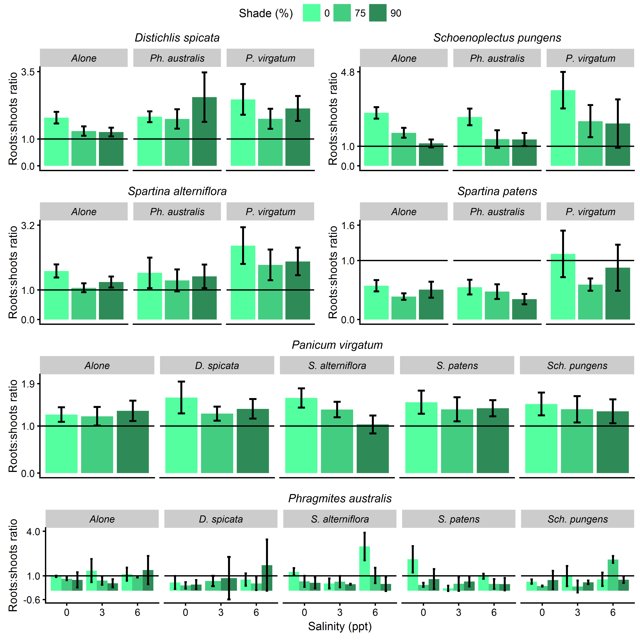

**Figure 2** Roots:shoots ratio of each study species at the end of the experiment. Each species grew alone or accompanied by a neighbor species (indicated inside the grey boxes), and at different levels of shade and salinity. Salinity levels are only represented for the species in which this factor had a significant effect (i.e., *Phragmites australis*); in the rest, the results are the average of the three levels. Bars represent the average roots:shoots ratio per treatment, brackets the 95% confidence interval.

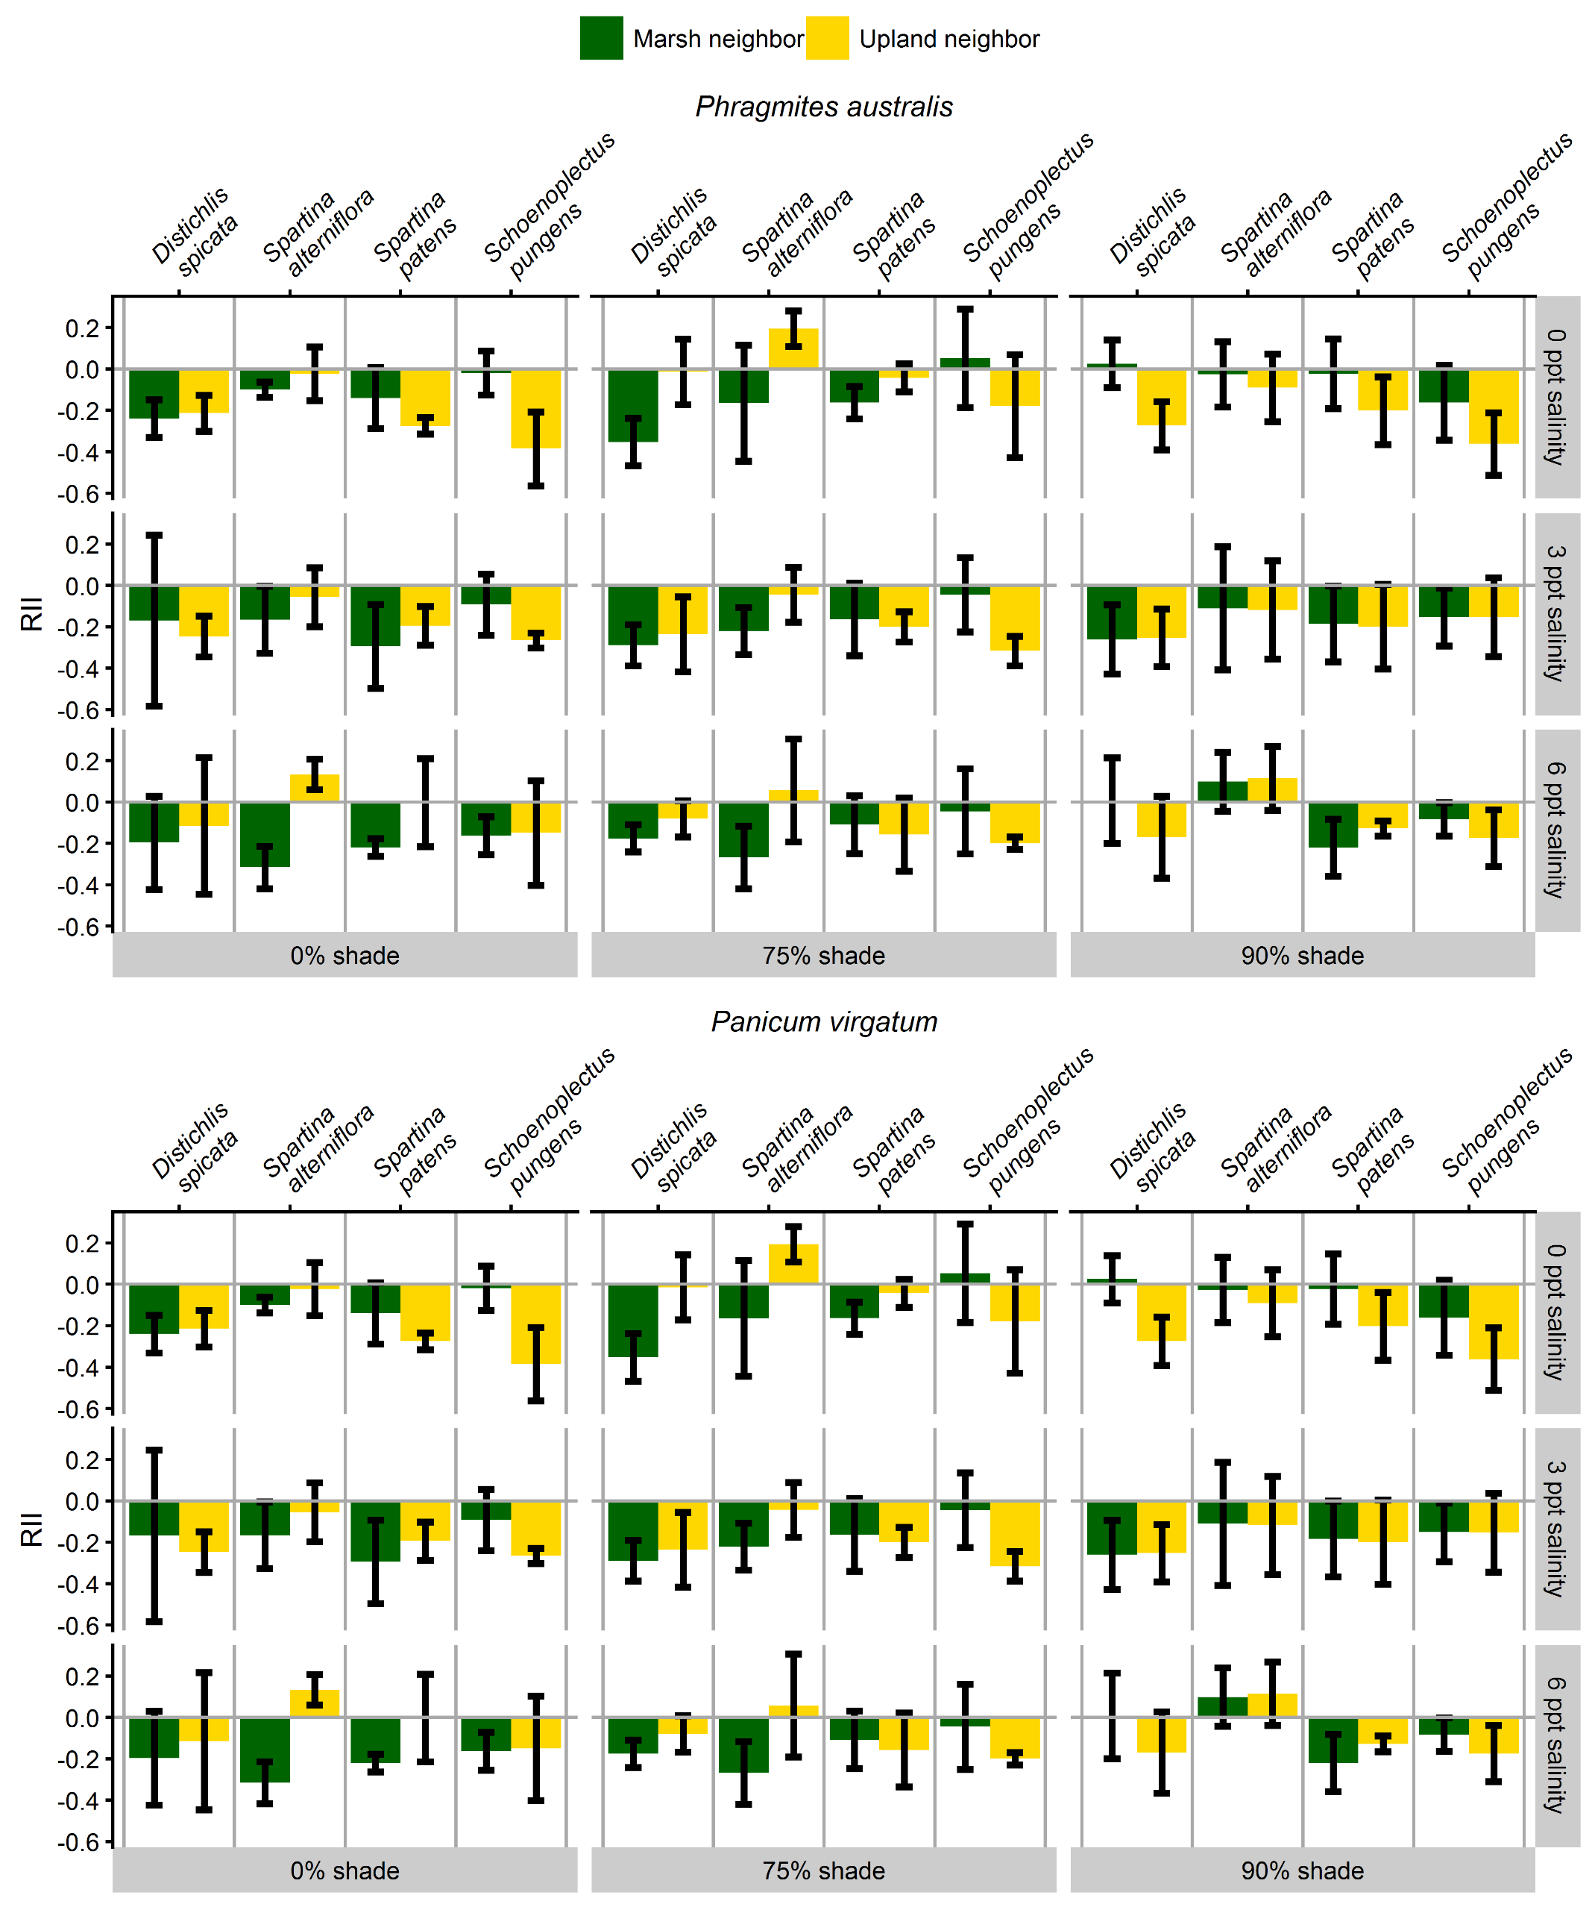

**Figure 3** Relative interaction intensity (RII) of each combination of upland (*Ph. australis*, *P. virgatum*) and marsh (*D. spicata*, *S. alterniflora*, *S. patens*, *Sch. pungens*) species growing together. Each combination was grown at different levels of shade and salinity. Bars represent the average RII per species and treatment, brackets the 95% confidence interval.

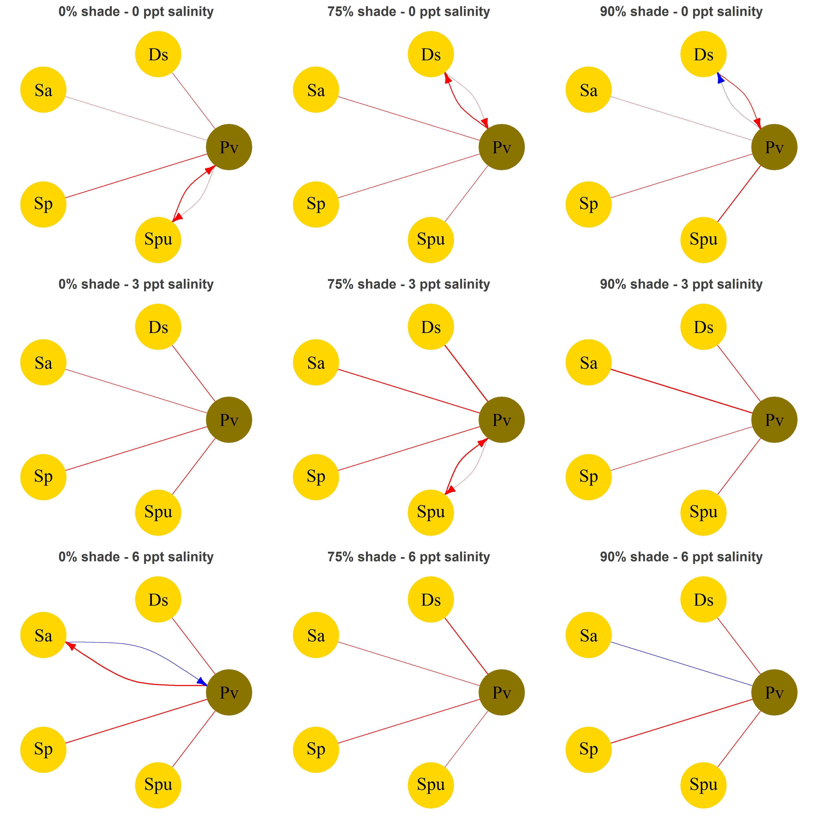

**Figure 4B** Same as figure 4, but only *Panicum*.